**MWANZO BARAKA INFORMATION**

**SYSTEM**

**NAME**: EMMANUEL NGUGI

**INDEX**: 15309101027

**SUBJECT**: COMPUTER STUDIES_451/3

**YEAR OF EXAMINATION**: 2017

**SCHOOL**: BURIERURI BOYS’

**SUPERVISOR**: MARTHA GAKII

## 

ACKNOWLEDGEMENT

First I’d like to God for his overall care, life and health that I’ve had before and in the course of this of this project.

Secondly I acknowledge the support given to me by parents, relatives and others who have had a project to do in the previous years.

I’d also like to thank our computer teacher, the school and the rest who have really played a part in the development of this information system.

Lastly, I write my gratitude to my friends who we have shared ideas with so that this information system a good one. That is really good of you. Thank you all.

DEDICATION

This project is dedicated to Burieruri boys’ secondary school for the support they have given to me so that this work goes to completion.

The project is also dedicated to all people who have aided its development because were it not for them it would not be completed.

Lastly, I dedicate this project to all my friends who also may or have played a role in coming up with ideas that have been used anywhere in the project.

# 

# TABLE OF CONTENTS

TABLE OF CONTENTS 4

LIST OF FIGURE 7

CHAPTER ONE 8

1. Introduction 8

PROJECT CHARTER FOR MWANZO BARAKA INFORMATION SYSTEM 10

CHAPTER TWO 11

PROBLEM DEFINITION AND ANALYSIS 11

PRELIMINARY INVESTIGATION 11

PROBLEMS OF THE EXISTING SYSTEM 12

SCOPE OF THE SYSTEM 13

MY VISION 13

FEASIBILITY STUDY OF THE PROPOSED SYSTEM 14

CHAPTER THREE 16

FACT FINDING 16

Introduction 16

Questionnaires 16

Interviews 17

OBSERVATION 17

FACT FINDING REPORT 18

SUMMARY OF THE CURRENT SYSTEM 18

Advantages Of the current system 18

Disadvantages 18

SUMMARY OF THE PROPOSED SYSTEM 19

Advantages Of the proposed system 19

Disadvantages 19

CHAPTER FOUR 20

SYSTEM DESIGN 20

1.2 DETAILED DESIGN. 23

1.2.aTable Design/Normalization 23

1.2. A.1 Relationships 25

1.2.b File and data stores design 26

1.2. b. Input design 27

Output design 30

CHAPTER 5 35

USER GUIDE: 35

SYSTEM REQUIREMENTS: 35

Launching the system 35

EDITING THE DATABASE: 36

CHAPTER 6 37

CONCLUSION AND RECOMMENDATIONS: 37

CONCLUSION: 37

RECOMMENDATION: 37

APPENDIX 1: SYSTEM FLOWCHART SYMBOLS 38

39

40

40

40

40

40

APPENDIX 2: TECHNICAL TERMS 41

APPENDIX 3 42

Questionnaire 43

43

REFERENCES 44

# LIST OF FIGURE

*Figure 1Mwanzo Baraka Logo* 9

*Figure 2. System flowchart* 19

*Figure 3. Program flowchart for loans borrowed* 20

*Figure 4Dividends flowchart* 21

*Figure 5Group details table* 22

*Figure 6Individual members table design* 22

*Figure 7Monthly contributions table design* 23

*Figure 8Loans Borrowed Table design* 23

*Figure 9Total registration fees table design* 23

*Figure 10Relationships extract* 24

*Figure 11Individual members details* 25

*Figure 12Dividends records* 26

*Figure 13Form design for group details* 26

*Figure 14Individual members data input interface* 27

*Figure 15Monthly contributions input form* 27

*Figure 16Loan borrowed input design* 28

*Figure 17Input form for registering groups* 28

*Figure 18Switchboard form* 29

*Figure 19Loans report* 30

*Figure 20Total contributions made* 31

*Figure 21Dividends report* 32

*Figure 22All members report* 33

*Figure 23Microsoft office Activation prompt* 34

# 

# CHAPTER ONE

## 1. Introduction

CASE STUDY

Mwanzo Baraka organization is a self-help group that intended to improve the economic status of its members through pooling of financial resources. The organization sustains itself through registration fees of its members, monthly contributions, interest accrued through loans given to members, and penalties for delayed payments. The members benefit by getting cheap loans from the organization.

Membership to the organization is by registration. There are two types of membership; individual and group. Group membership constitutes of two or more individuals who have common interests. An individual member pays a registration fee Kshs.2, 000 while a group pays Kshs.5, 000. During the registration of individuals, personal details are captured. When registering a group, details of the group and those of its members are captured.

Individual member contributes a monthly share of not less than Kshs.1, 000 to the organization. For those registered under a group, each member contributes a monthly share of not less than Kshs.1, 000 where Kshs.200 is the group share contribution by the member. All monthly contributions are treated as share for contributor and attract annual dividends.

Members can borrow loans from the organization based on their total shares. Members registered as individuals can be loaned up to three times their share contribution. The repayment period does not exceed three years and the loan attracts interest at a rate of 1.2% per month on the principal amount borrowed. Members registered under a group can be loaned up to four times their individual share contribution. The repayment period does not exceed four years and the loan attracts an interest at a rate of 1% per month on the principal amount borrowed. A group can also get a group loan, amounting to three times the group’s total share contribution which attracts interest at the rate of 0.8% per month payable within five years. All payments to the organization are monthly and must be made by the last day month. Any defaulted payments are penalized at a rate of 10% per month.

Every end of the year, the organization determines the total interest charged on all loans and total penalties on defaulted amounts. 60% of this amount is paid as dividends to the shareholders each getting an amount proportional to their total share contributions. The balance is retained to run the organization.

The proposed computerized system will therefore electronically:

• Maintain records of members and groups

• Maintain records of registration fees

• Maintain records of monthly contributions

• Maintain records of loans borrowed

• Compute loan repayments and interest.

• Compute income for the organization

• Compute dividends to each share-holder.

• Generate reports on demands.

1. **OBJECTIVES OF THE PROPOSED SYSTEM**

The proposed computerized system is therefore expected to;

* + - * Keep records of member registration, loans and monthly contributions
      * Do calculations in loans and dividends.
* Reduce the workload with the manual system.
* Utilize resources economically by reducing use of stationary and reducing the number of employees
* Improve services offered to the members of the organization.
* Increase the overall profit of the organization by online analytical processing that enhances efficient decision making.
* Solve insecurity issues that have been with the current system.
* Network computers so as to support distributed processing.
* Ensure accuracy of data entered in any table so as to avoid inconveniences

## PROJECT CHARTER FOR MWANZO BARAKA INFORMATION SYSTEM

Nakuru Investment Buildings, Po.Box. 22, Nakuru, Kenya

Email: mwanzobaraka67@gmail.com

Phone +254-780344980,

PROJECT CHARTER



Figure 1Mwanzo Baraka Logo

**PROJECT NAME**: MWANZO BARAKA INFORMATION SYSTEM

**PROJECT DEVELOPER**: KARITHI EMMANUEL NGUGI

# CHAPTER TWO

## PROBLEM DEFINITION AND ANALYSIS

Mwanzo Baraka Organization has suffered many problems in managing themselves using a manual system. The system functions though not as expected by the organization and its members.

This has called for a need to develop a computerized system to meet the expectations of the organization.

## PRELIMINARY INVESTIGATION

Preliminary investigation and feasibility study of the current system and the proposed system were carried out through

* Observations
* Interviewing the heads of the organization, the staff and some members of the organization.
* Questionnaires offered to the staff and members of the organization.

## PROBLEMS OF THE EXISTING SYSTEM

During the study, these are the problems that were discovered with the existing system.

* **Data Insecurity**: The manual systems’ data is stored in ledger books and registers and that has rendered it insecure since anyone can access the data freely.
* **Inaccuracy**: Problems concerning inaccurate entry of data has been a major problem with the current system. This has led to a lot of inconveniences especially while manipulating data involving money calculations.
* **Poor keeping and retrieving of records**: The manual system uses registers to keep records which proves a hard time in retrieving the records
* **Slow processing:** There has been manual tallying of the loans, dividends and other money calculations. This has been followed by wastage of time and slow processing of data.
* **Low income**. This follows the high number of working staff in the organization which can be reduced by half if a computerized system is implemented in the organization.

## SCOPE OF THE SYSTEM

The proposed computerized system will be developed using Microsoft Access which will support all these highlighted operations.

• Maintain records of members and groups

• Maintain records of registration fees

• Maintain records of monthly contributions

• Maintain records of loans borrowed

• Calculate loan repayments and interest.

• Calculate income for the organization

• Calculate dividends to each share-holder.

• Generate reports on demands.

## MY VISION

I have come up with the following recommendations for the proposed Mwanzo Baraka information system.

1. Networking of computers to support distributed processing.
2. Enhance the manipulation of records, easy input and retrieval.
3. Reduce errors incurred while entering data.
4. Adoption of ICT devices like printers, computers, external storage devices and computer networking to ease access and manipulation of stored records by the group management and the employees
5. Ensure conducive environment for employees

## FEASIBILITY STUDY OF THE PROPOSED SYSTEM

In feasibility study, the costs and benefits of the proposed system are established. The feasibility studies carried are as follows.

1. OPERATIONAL FEASIBILITY

The proposed system is very user friendly and gives the user all the comfort. It is easy to learn and understand.

Unlike the current system, this system will reduce loads of work by coming up with distributed processing hence the user does not have to work on the whole system because the processing will be distributed between various departments in the organization.

1. TECHNICAL FEASIBILITY

The system has sufficient technology required to meet the objectives. Using the Database Management Software, there is ease of manipulation of data using the technology available in the Graphical User Interface in it.

1. SCHEDULE FEASIBILITY

The System Development Life Cycle took exactly seven months.

The First two months were used in case study and data collection. One month was used in specifying the requirements and system design. Two months were used in system construction while the remaining two months were used for system implementation, review and maintenance

**d**. ECONOMIC FEASIBILITY

According to the feasibility study, the proposed system is found to be more economic because the output benefit is more than the cost input. This was estimated for a span of one month after the implementation of the system.

**COST INPUT**

*Running Cost- Electricity, and printing stationery Kshs.14, 000 per month*

*Staff payments per month Kshs.184, 000 per month*

**TOTAL**  ***Kshs.198, 000 per month***

**SAVINGS**

*Reduced staff savings Kshs.300, 000*

*Abolishment of stationary Kshs.2, 800*

**TOTAL SAVINGS** ***Kshs.302, 800***

**7. CONCLUSION**

The proposed system is therefore economic, user friendly and has enough technology to keep the organization on the trend. The study therefore renders the system feasible to be accepted by Mwanzo Baraka organization.

# CHAPTER THREE

## FACT FINDING

## Introduction

Here, data collection methods are involved to study the current system, its disadvantages, advantages and the expectations of the organization with the new system

1. **Data collection**

Real fact finding and information gathering-To look for key things that are required in order to start working on the proposed information system.

#### METHODS USED

## Questionnaires

The head of the organization, the staff and some members were offered with questionnaires they had to fill so as to come up with a factual account to aid in developing a new system. The questionnaire method span was one month. The questionnaire used was open. (Sample questionnaire on the appendix)

#### Advantages Of questionnaires

* The respondent has a lot of time with the questionnaire paper hence he will give all without rushing hence giving reliable information.
* The method was cheaper than other methods that may have been proposed to use.

#### Disadvantages

The respondent cannot seek clarification because there is no physical contact with the researcher and hence information has risk of biasing or blank spaces in questionnaires.

## Interviews

The research team had to spend some time doing interviews on the staff of existing system investigate on the day to day process, list them down so as the problems are covered under the new system. (Sample interview of the interview)

#### Advantages

* The respondent may give a lot of information since the interview is not closed for choices and the interview is in contact with his respondent
* The respondent may seek clarification during conversation with the interviewer.

#### Disadvantages

* The interview process consumes a lot of time.

## OBSERVATION

We had to spend some time watching and observing as the staff in various departments carried out the day-to-day processes that help in decision making.

We had also to observe the registration of new members and how records are manipulated and how calculations are done.

#### Advantages

* It provides information on areas where explanation cannot provide full information.

#### Disadvantages

* Those being observed may change behaviour in the course of observation.

## FACT FINDING REPORT

The current system is manual. The organization uses a ledger book, register and other stationery in their day to day process. A calculator is used to compute the money bulk.

The expectations of the staff from the proposed system are that it will help in the decision making process and simplify work.

## SUMMARY OF THE CURRENT SYSTEM

In short, the current system makes use of stationery to do registration, keep records and do the computations. The organisation has employed many staff because there is a lot of work to be done in their day to day process and in manipulating the data.

## Advantages Of the current system

* It has created jobs to many people who work as staff in the system.
* The data does not have a risk of virus attack since it is not computerized.

## Disadvantages

* It is costly due to the number of employees performing various jobs in the organization.
* Inaccuracy of data entered in books may result to inaccurate output
* The current system data is insecure and can be accessed by unauthorized people.
* It involves wastage of time in processing data.
* It is difficult in searching for existing records.

## SUMMARY OF THE PROPOSED SYSTEM

The proposed system is computerized and will meet the expectations of the organization. This is because it will:

* + Support networking, sharing of resources and distributed processing hence it is very efficient.
  + It will reduce the number of workers hence it will save money to run the organization

## Advantages Of the proposed system

* It will process data electronically hence it is faster and reliable.
* It will provide data security by prompting a user to enter password in accessing any module of the system.
* The database software used will help in generating reports that summarizes a given time schedule.
* It will reduce the number of workers and probably employ people with computer skills.

## Disadvantages

* It is costly in purchasing the requirements and running them.
* There is risk of virus attack

# CHAPTER FOUR

## SYSTEM DESIGN

* 1. PRELIMINARY DESIGN

This describes the functional capabilities of the new system. System flowcharts and program flowcharts have been used to describe the functionality of some critic modules in the system.

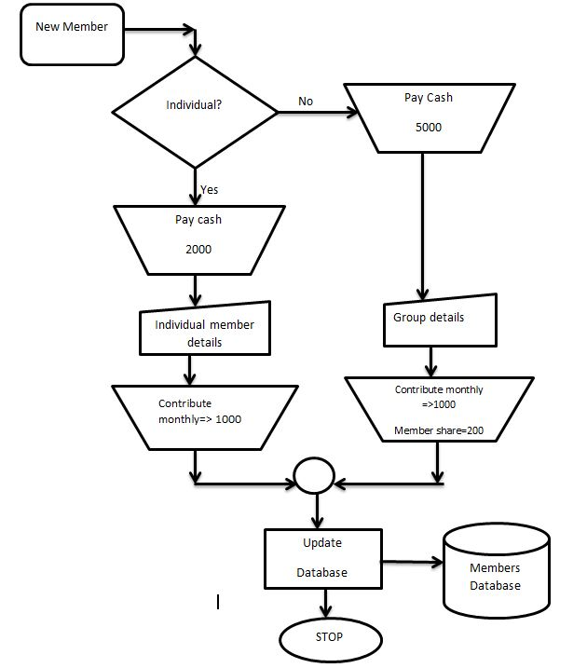

Figure 2. System flowchart

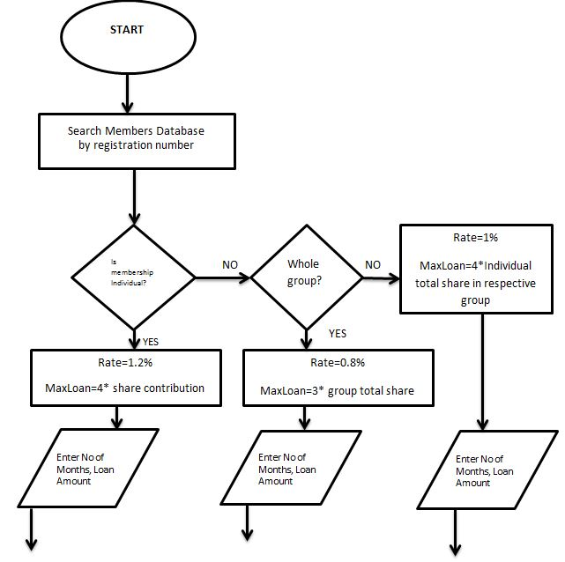

k

Figure 3. Program flowchart for loans borrowed

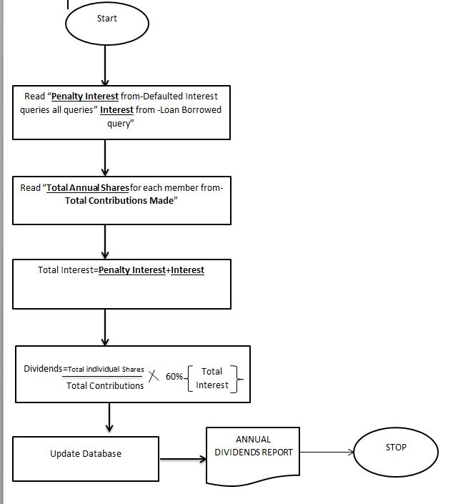

Figure 4Dividends flowchart

## 1.2 DETAILED DESIGN.

The detailed design is covered here for various system functionalities

1. Table design normalization
2. Files and data stores design
3. Input design.
4. Output design.

## 1.2.aTable Design/Normalization

Groups table design. This is the design used in group details for all group tables the **highlighted sections show primary keys** in the tables.

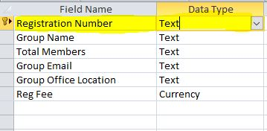

Figure 5Group details table

This is the table design used in individual table details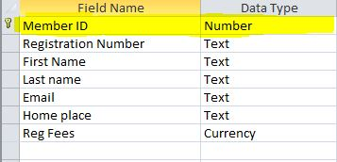

Figure 6Individual members table design

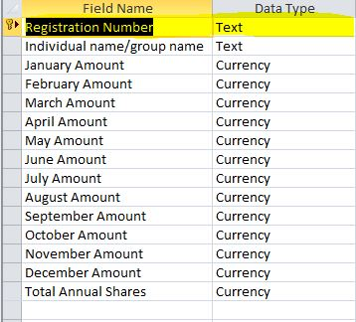

Figure 7Monthly contributions table design

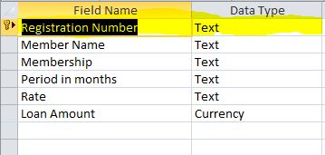

Figure 8Loans Borrowed Table design

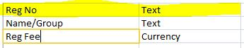

Figure 9Total registration fees table design

## 1.2. A.1 Relationships

The screen shot shows how tables in the database are related in one way or the other. It shows how members in individual group table are linked to those others in the related table. The parents table have been related to child tables through primary keys to ensure that data in child tables is validated in parent table.

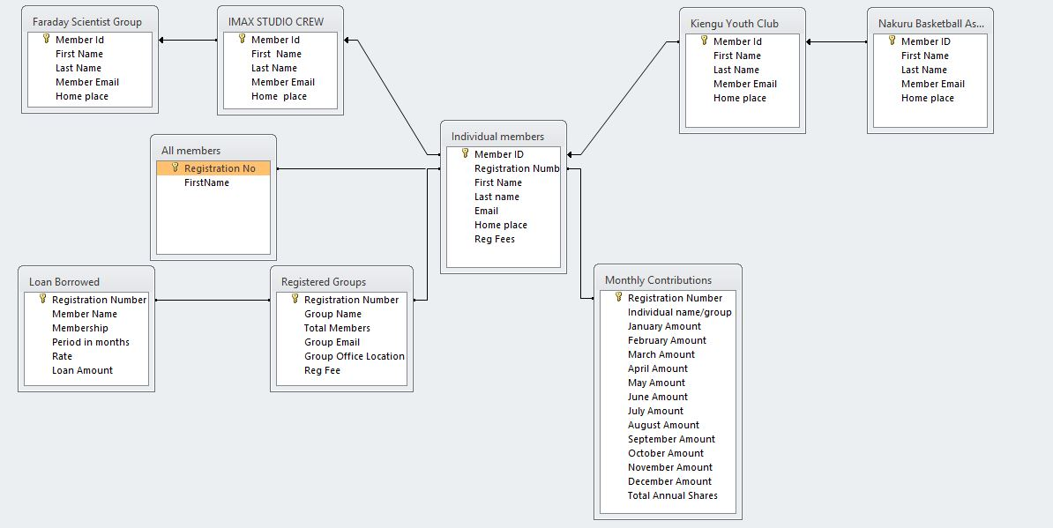Figure 10Relationships extract

## 1.2.b File and data stores design

The main data stores are tables. These sample shows preview of some tables in datasheet view and with test data put to prove the functionality of the system.

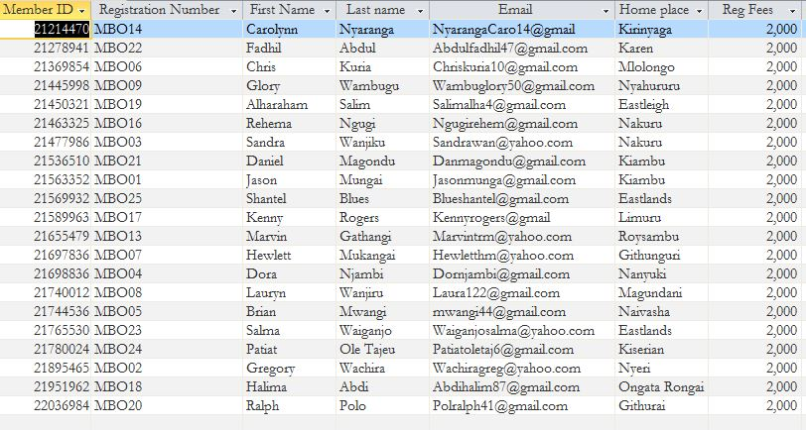

Figure 11Individual members details

This table in datasheet has been created to compile all interests from the queries. The total amount is then used directly in calculate the 60% of the total so that it is shared among the members of the organisation in dividends query.

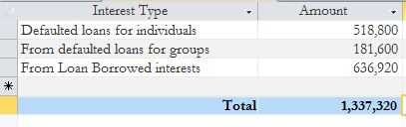

Figure 12Dividends records

## 1.2. b. Input design

Input is done by use of forms. Forms are made with commands to ease the input and navigation through the records. These are data input designs used to provide a user interface that is friendly to interact with.

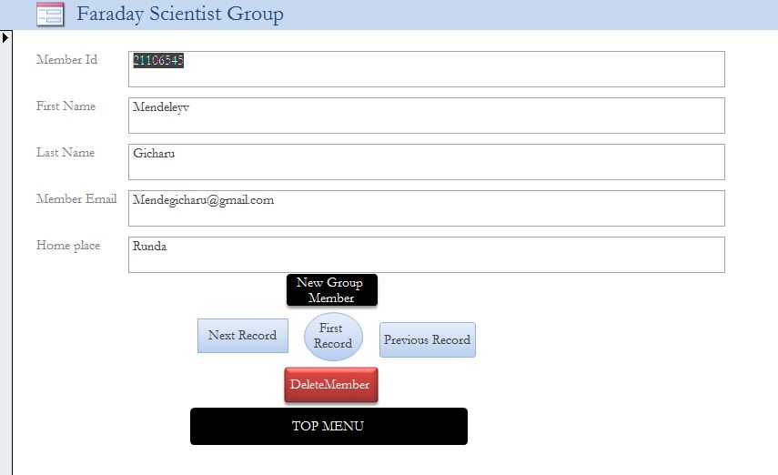

Figure 13Form design for group details

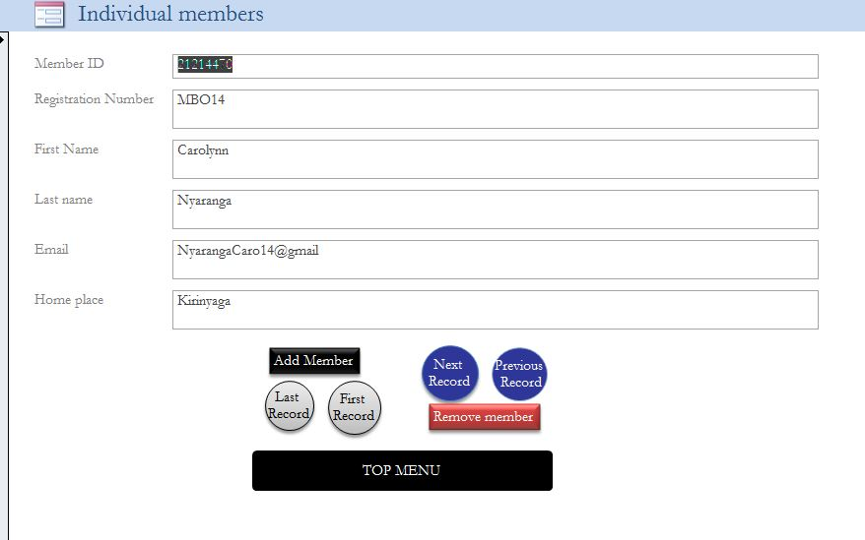

Figure 14Individual members data input interface

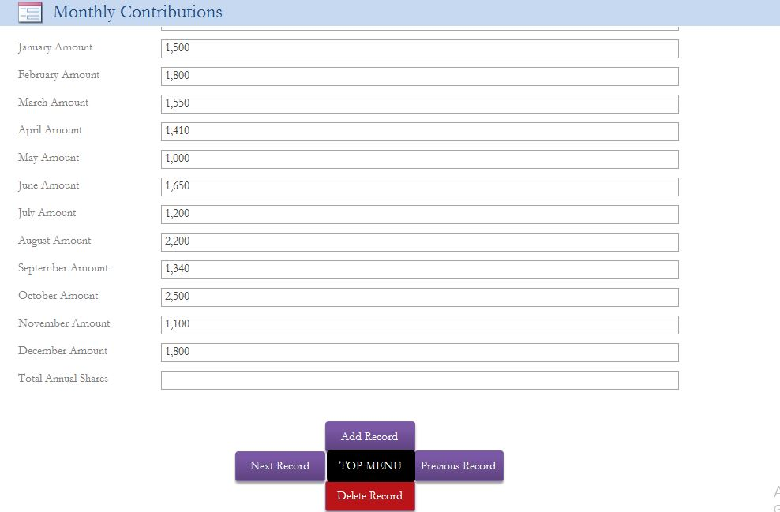

Figure 15Monthly contributions input form

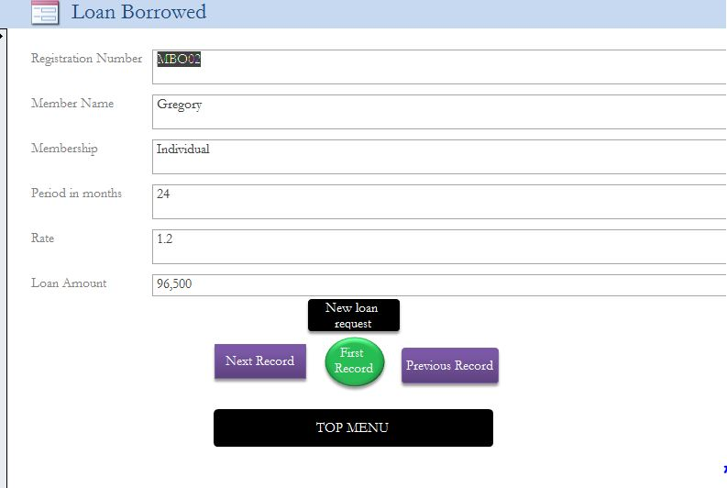

Figure 16Loan borrowed input design

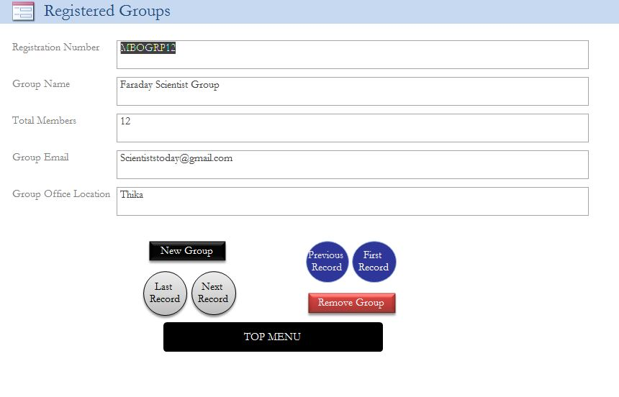

Figure 17Input form for registering groups

This switchboard is used in navigating through the database. It launches right when the database is opened.

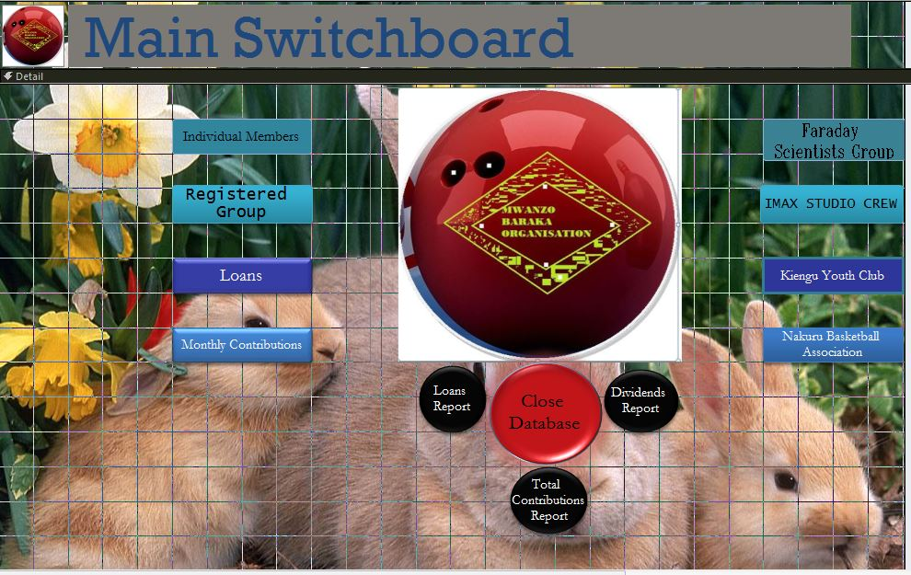

Figure 18Switchboard form

## Output design

This includes both screen and printed output designs. Reports in database are used to give summary for particular queries and tables. The output designs for Mwanzo Baraka organisation are as follows. 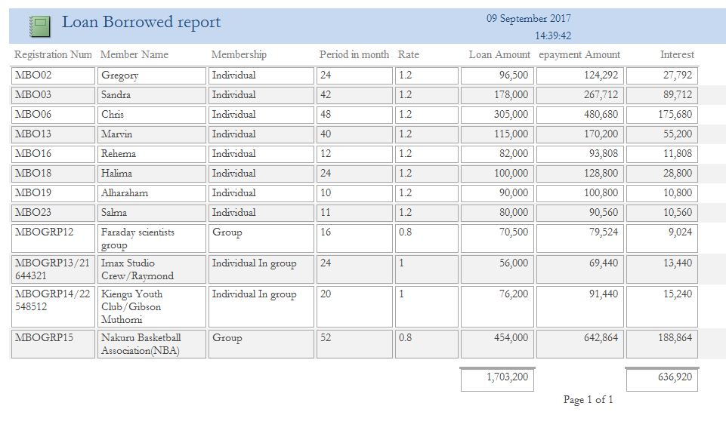

Figure 19Loans report

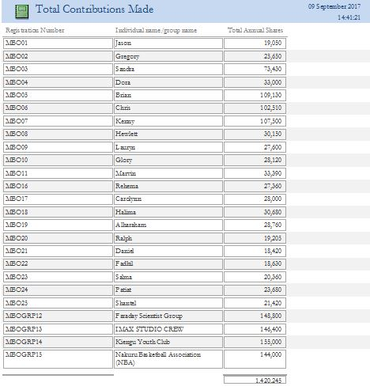

Figure 20Total contributions made

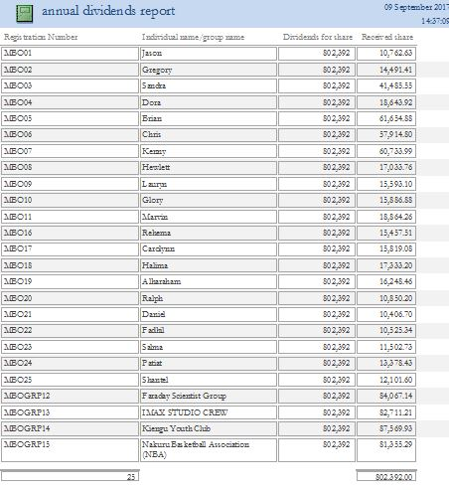

Figure 21Dividends report

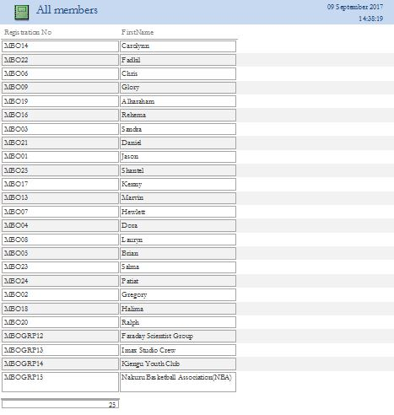

Figure 22All members report

# CHAPTER 5

## USER GUIDE:

## SYSTEM REQUIREMENTS:

The system requires both hardware and software devices, as listed.

* Windows Xp, 7, Vista or a later version.
* Microsoft office 2007 or later.
* 2 GHz processor or higher.
* Free memory of at least 100mb.
* Antivirus program to avoid virus risk.
* Printer
* Mouse
* Keyboard

## Launching the system

From the storage media or image containing the system database:

* + Copy to an open location on the desktop to enable ease of access
  + Double click the database file you have copied
  + On the prompt box that appears. Click on close

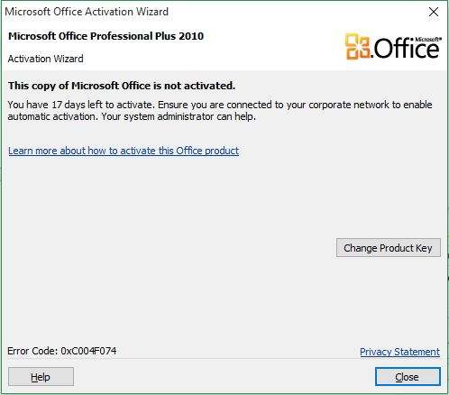

Figure 23Microsoft office Activation prompt

* Just above the database objects, click on enable content.

## EDITING THE DATABASE:

#### EDITING RECORDS:

* Open the form in which you want to edit records.
* Go to the specific record you want to edit, ensure you save every time you edit a record.
* When you have edited click on the save button.

#### ADDING RECORDS:

* Open the form you what to add records.
* Click on the Add New command.
* Add the record you want, save each record as you enter it.
* When you have added, click on the exit or close button to close.

#### DELETING RECORDS:

* Open the form you want to delete records from.
* Go to the specific record you want to delete.
* Click on the delete button.
* In the message box that appears, click ‘Yes’.
* Save and Click on the exit or close button to close.

#### Navigation

The forms starting with the switchboard provide command buttons that aid in navigating through the forms easily.

# 

# CHAPTER 6

## CONCLUSION AND RECOMMENDATIONS:

## CONCLUSION:

In conclusion, Mwanzo Baraka Information system is a computerised system that will meet the objectives as required and solve the problems highlighted in the current system. By using the database application, data updates itself anytime there is change or addition because of the relationship between tables.

In querying dividends, the user manually identifies all interest and then updates the formula for calculating the dividends

Income for the organisation is also tallied from all queries, and tables containing registration fees and monthly contributions totals

## RECOMMENDATION:

I would recommend that staff of Mwanzo Baraka to be equipped with computer skills that will help in the ease of use of the new system.

I would also recommend that the system to be adopted by other self-help groups with the same problems by applying necessary changes to the new Mwanzo Baraka Organization Information System.

## 

## **APPENDIX 1**: SYSTEM FLOWCHART SYMBOLS

The following are symbols used in the documentation of this program.

***DESCRIPTION***

***SYMBOL***

Starts and stops the flow of the program

***Parallelogram***

Identifies input or output

***Rectangle***

Identifies a computerised process

Cylinder

Identifies a disk master storage

***KITE***

***.***

Used when a decision is to be made and returns yes or no

Arrow shows flow of

Shows an activity that triggers other processes.

Shows a manual process

Trapezium

## 

Shows generation of report

## 

Shows a off page connector

## 

## 

On page connector

## 

## 

Shows input using the keyboard

## APPENDIX 2: TECHNICAL TERMS

* **System**: Organisation of components that function together to achieve a common goal.
* **Flowchart**: Graphical representation of an algorithm that shows logical sequence of activities.
* **Forms**: Place where the user inputs data to the computer.
* **Records**: Collections of related fields that represent a single entity.
* **Feasibility**: Study carried out to establish the benefits and costs of a new system. Data input: Data entered into the computer through the keyboard for the conversion of the program into machine readable form.

## APPENDIX 3

This shows sample data collection methods used in fact-finding phase of the system

Interview

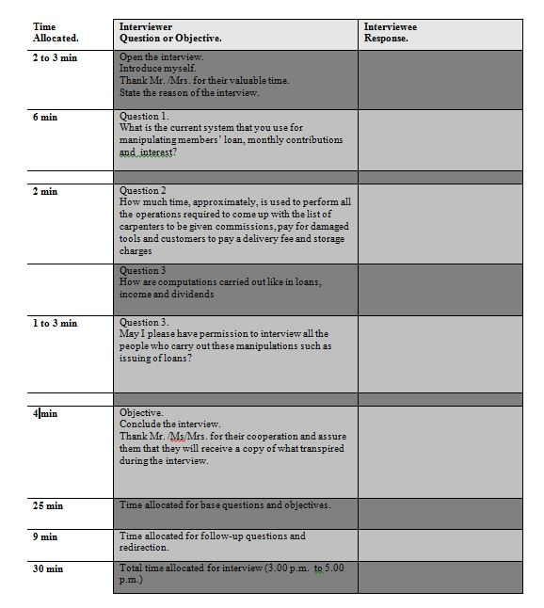

Figure 24Sample interview

## Questionnaire

## 

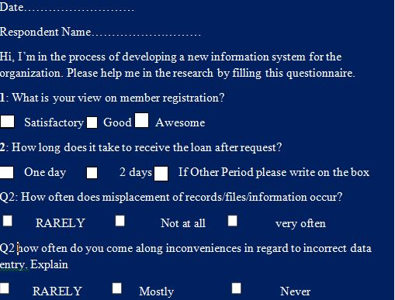

Figure 25Questionnaire

## 

## REFERENCES

The bibliography shows a list of books and reference materials used in developing the project.

* **S Mburu and G.chemwa**:longhorn secondary computer studies book 3 longhorn publisher 2007
* **S.MBURU and G.CHEMWA**:LONGHORN secondary computer studies book 4

#### INDEX

***451/3 Computer Studies paper three…...........cover page***